Division of Labors in Insects Society

MD. TurzaIbna Muksud1,Amina Hossain2&Sifat Momen3

1Department of Computer Science and Engineering

University of Liberal Arts Bangladesh

Email: [turza.muksud.cse@ulab.edu.bd](mailto:turza.muksud.cse@ulab.edu.bd)

2Department of Computer Science and Engineering

University of Liberal Arts Bangladesh

Email: [amina.hossain.cse@ulab.edu.bd](mailto:amina.hossain.cse@ulab.edu.bd)

3Department of Computer Science and Engineering

University of Liberal Arts Bangladesh

Email: [sifat.momen@ulab.edu.bd](mailto:sifat.momen@ulab.edu.bd)

**Abstract**— Division of the labor is one of the significant areas of research within the context of the insect life. In this paper, we look at low insect are divided their particular task in their real life. In this paper we try to represent an agent based model by some simple formula. We depth in analysis how can insect are properly utilize their energy and how the graphical figure of the average energy looks like in every time duration. Our simulation results express a number of interesting discover including: (1) the aunt utilization decreases with the increase in the number of aunt and vice versa, (2) the aunt utilization increases with the increase in the quantity of task and vice versa.

**Keywords**— Agent based model, division of labor, energy efficiency.

**1 INTRODUCTION**

**D**ivision of labor is the spilt of task any economic system, organization and any work so that participants may specialize [1, 2]. The usefulness of an ant society can be mostly contributed to the fact that division of labor occurs in a society. Many multiple agent systems like biological or artificial construct of agents that separate the tasks. Division of labor is divided by some stringent and predetermined formulas or patterns. This power to allocate the tasks among the agent is mention to as task allocation or division of labor. Sometime the demand can change due to impatience caused by internal or external factors. They are so because ants are smile entities, non-cognitive, distributed and autonomous and yet the overall colony performs of labor fault tolerate, flexible and seemingly intelligent. As motive for division of labor in computer systems, ant societies are brilliant.

The rest of paper is organized as follows: In section II, a background of task allocation and labor system is given followed by our proposed model in section III. Experiment details and their results are discussed in section IV. At last the paper concludes in section V with a summary of our findings and potential implications in our further research endeavors.

**2 BACKGROUND**

2.1 Division of labor in ants

There are more than 12000 species of ants and they show different kinds of division of labor. The most primary form of division of labor in anta is the reproductive division in labor. Where the individuals only limited to one, that is called queen. Only queen is responsible for reproduction. But the other female ants of the colony is called worker. They work like as non-reproductive agents. Apart from the primary division of labor, there are three kinds of division of labor found all the different species of worker ants. They are: (1) Worker polymorphism (2) Age polymorphism and (3) Individual Variability.

The ants that display worker polymorphism over look to specialize in particular task because of their morphological advantages. {3} In case of the Pheidole ants there exist two kinds of workers: major workers and minor workers. Major worker have disproportionately large heads and strong mandibles. They tend to specialize in task that laborites such as guarding a nest from intruders and transporting heavy objects one place to another place. Minor workers are tending to small in size. They are specialize in softer task like cleaning, feeding the young brood members.

Some species of ant like Pgonomyrmex barbatus in which the task prepared by the workers tend to change by their age. Like older workers specialized for foraging and carrying food items and younger to closer to the queen {4}.

However the most species of ant tend to exhibit individual variability wherein they are selected the task by their experience and learning on different factors. Ants are very easily adapting their environment and respond to the change in demand of the colony. In case the red harvester ants the worker class tends to takecare a number of tasks like foraging, patrolling, feeding to the younger brood members and cleaning nest. Some of ants doing other kind of work are found to switching to nest cleaning job in response to the increased colonial cleaning the messes {5}.

This kind of behavior is the key of the useful organization and the successful colony.

**3 PROPOSED MODEL**

To model division of labor in insect’s society, here agent based modeling is used where tasks are given to agents (Ants). Netlogo[9] is used to create this model.

The specification of the proposed model is given below:

**3.1 Specification of the model**

In this model, the environment is populated with some ants (white and blue ant), foods in some random places and a nest of ants. The agents (ants) have some major tasks. Each major tasks, there are some sub-tasks.

The major tasks carried out by the simulated ants in our model are outlined below:

Searching: For this particular task, white ants are come out from the nest (middle of the environment) and search for foods.

Transporting: In this case, blue ants are started their task after a particular time (500 ticks) and started to follow smell of the white ants to grab the foods, and brought to nest.

Gather Energy: For every each move of both white and blue ants, they lose a minimum amount of energy. They must have to a minimum amount of energy to operate their tasks, or else they have to stop their tasks right there and come back to their nest to take rest and re-energized.

**3.2 Behavioral rules**

Each ant also has some sub-tasks behind of their major tasks.

White ants move randomly in order to find foods.

When an ant (white) find any foods in the environment, to make it easier to the carrier ants (blue) to find the food, the white ant leave a smell as marking the food color green to gray and converting the patch color from black to white.

A blue ant moves randomly until they grab any foods mark by white ants.

After grabbing foods from anywhere of the environment, blue ants take the foods to the nest as they know nest area.

After completing the task of grabbing and transporting, blue ants again move in the environment randomly.

Foods color will turn into yellow, when foods are brought into the nest.

As a minimum amount of energy is set for all ants, whenever their energy level go down under the minimum range ants (white and blue) change their color into red.

If the energy level goes down under the minimum range the move to nest automatically.

Blue ants lose double amount of energy, at the time of transporting the foods towards the nest.

**3.3 Parameters used in this model**

The following table summarizes the parameters used in this model.

TABLE: Parameters in the Model

|  |  |  |
| --- | --- | --- |
| Parameter Name | Value | Remarks |
|  |  |  |
| Number of ants | Variable | Here this parameter decides the number of white ants and blue ants individually in a particular situation. |
|  |  |  |
| Number of foods | Variable | This parameter specifies the number of foods randomly placed scattered or lump in the environment. |
|  |  |  |
| Minimum energy | 200 | This is the minimum energy that an ants must have to operate its task and to came back to nest. |
|  |  |  |
| Energy decrement | 0.21 | In every movement of ants, they lose some energy and this parameter specified the decrement rate. |
|  |  |  |
| Maximum wiggle angle | 45 | Here, it specifies the maximum of value wiggle angle of ants. |
| Loaded step length | 0.28 | The loaded step length of ants. |
| Unloaded step length | 0.18 | The unloaded step length of ants. |
| Vision range | 10 | The range that an ant can see. |
|  |  |  |
| Vision angle | 500 | Angular vision of ant. It can see 250 to its left and 250 to its right. |
|  |  |  |
| Find range | 1.6 | Any foods within this range, a white colored ant can see and mark out the food with a smell. |
|  |  |  |
| Grab range | 1.3 | When an ant is within in the grab range that means that ant can smell the marked food. So it can grab it and start transporting. |

**Figure 1:** Snapshot of the model 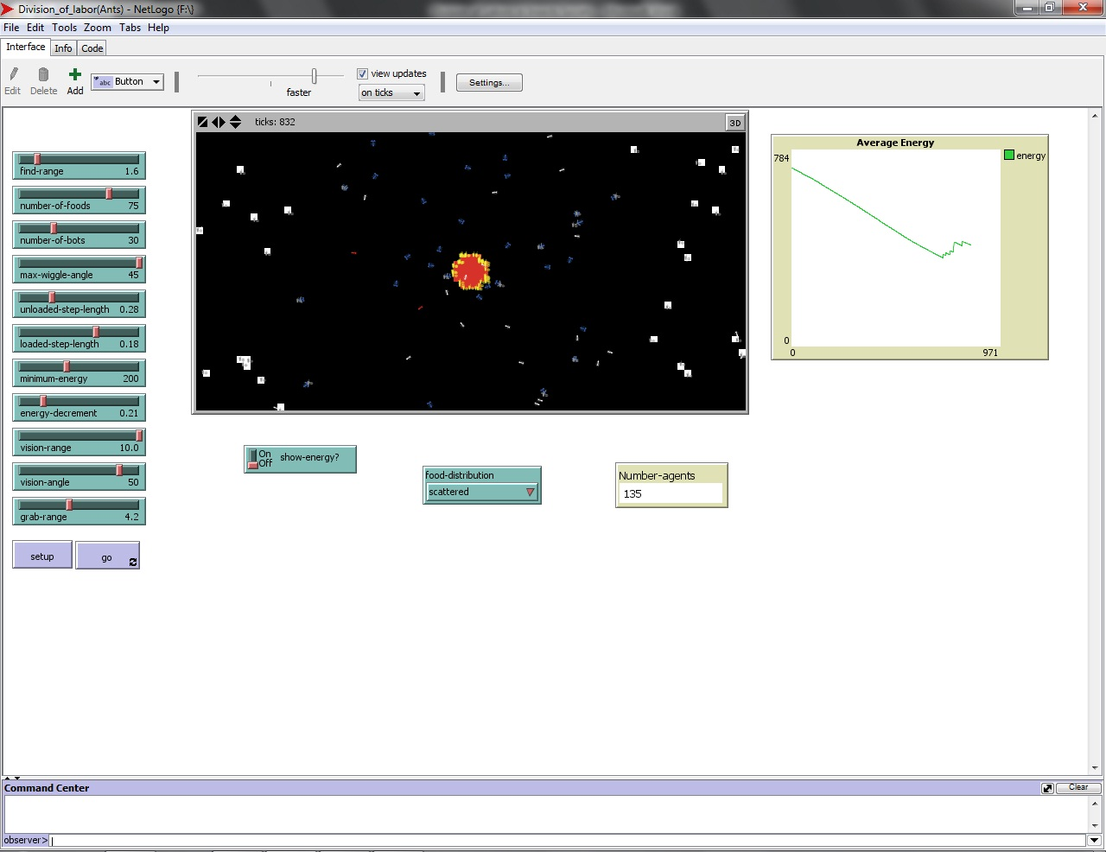

**Figure 2:** different properties that are populated in the environment.

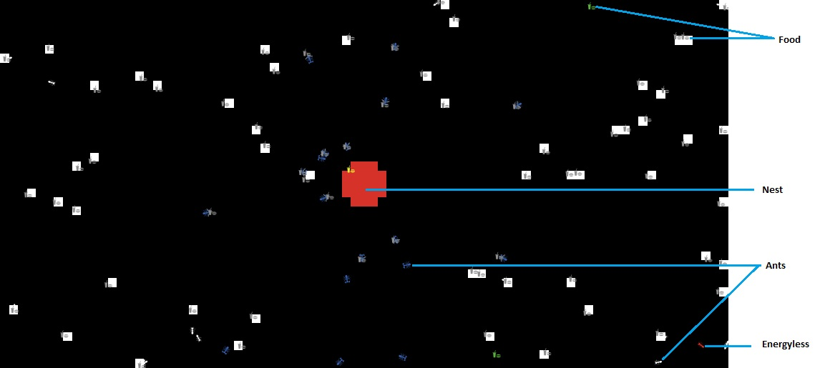

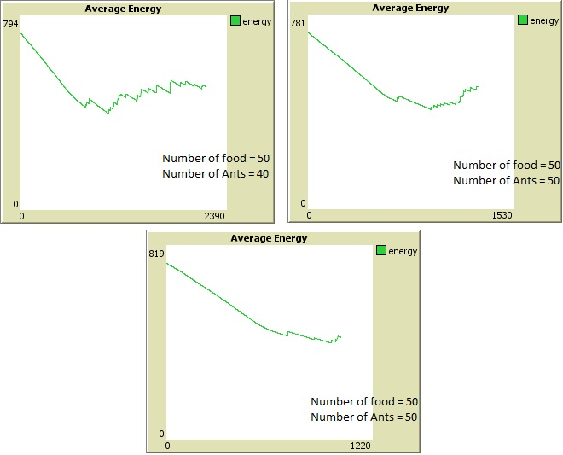

Figure 3: By keeping the number foods fixed and changing the number of ants, we can get above graph.

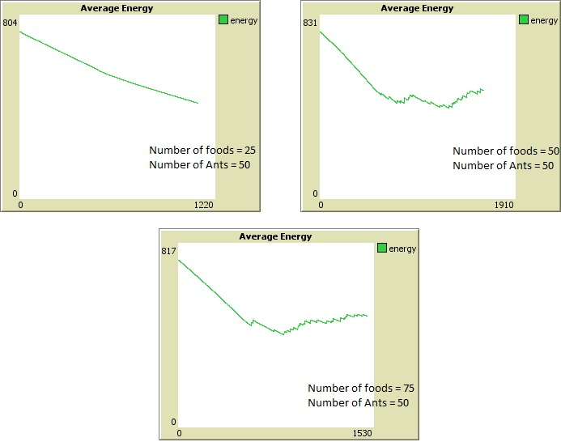

Figure 4: By keeping the number foods fixed and changing the number of ants, we can get above graph.

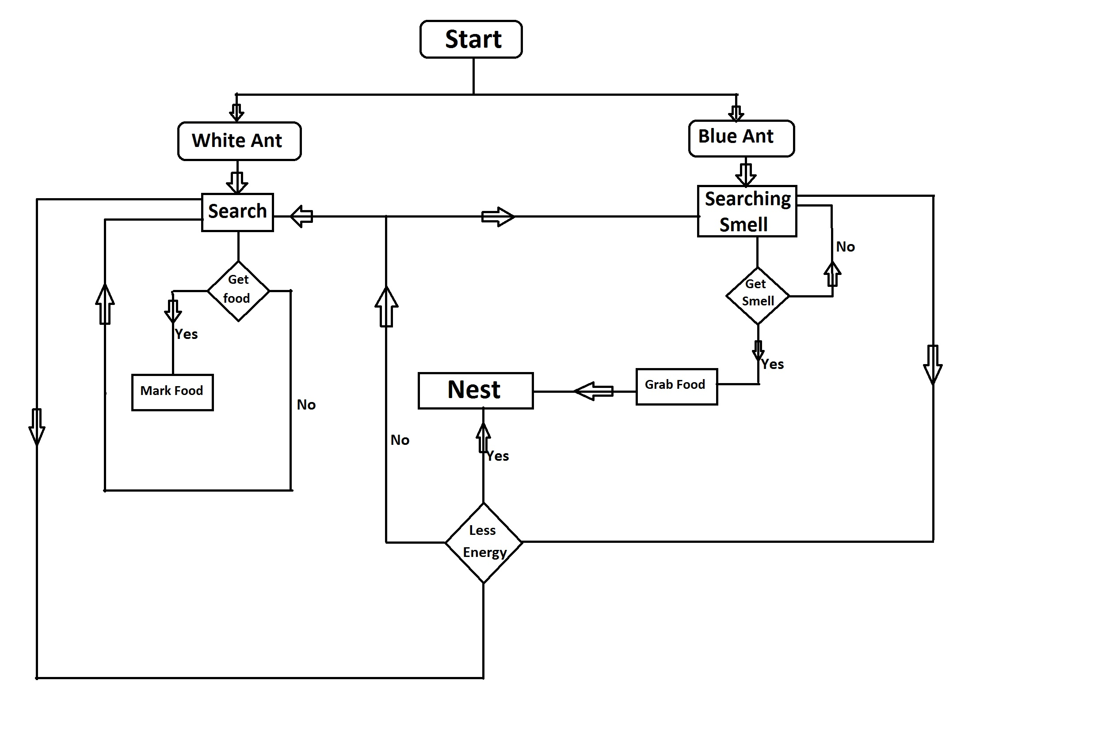Figure 5: Flow chart for the proposal model.

**4 EXPERIMENTS AND RESULTS**

Here, we discuss how the ants (white and blue) are participating to their tasks and how it affects the energy efficiency. If we increase the number of ants more than the number of foods, we can see the average energy of the ants is remain high. On the other hand, if the numbers of foods are more than the numbers of ants, most of the ants are not used. So the energy level of ants goes down without doing any related task.

**4.1 ENERGY EFFICIENCY**

Here, we investigate how the average energy of ants varies depending on the number of ants and the number of foods. It is not the right idea to increase the number of ants to increase the average energy of ants. In figure 3 and 4 different graph average energy are shown. By taking different number of ants and boxes, and repeating the experiment for many times, we get a good knowledge that when the average energy of ants increases or decreases. From the graphical value we can say that whenever the number of ants is more than the optimal number of ants (optimal value), the average energy of the ants (both white and blue) will be less. Similarly, if the number of ants in the environment is less than the optimal value, the average energy of the ants again declines. So, it is clear that, if there is a small number of ants (white and blue) remain in the world, the average energy of ants goes down. On the other hand, if there are too many ants more than necessity, then most of the ants do nothing and roaming around to find foods. And in the meanwhile, they lose a good amount of energy without doing anything. That is why, the average energy of ants are also decline.

**5 CONCLUSION AND FUTURE WORK**

In this paper we developed an agent based model where we investigate over the topic of “Division of Labors in insect Society”. Here ants are divided into two groups, where they have to do their own work that those are allocated for them at the beginning. So, no need to command the agents at time of experiments. In this model, we focus on the average energy of the ants. And we are willing to focus on the utilization of those ants and make a communication between the ants when the find a lot of foods in a same area in our future. And we also plan to use Genetic Algorithm (GA) in this model in future.

**REFERENCES**

1. S. Momen, “Design and modelling of decentralised task allocation mechanisms in groups of mobile agents”, PhD thesis,

University of Sheffield, 2011.

1. "Division Of Labour". *Wikipedia*. N.p., 2016. Web. 18 Apr. 2016.
2. Larsen, Jesper_Bach. "Division Of Labour In Simulated Ant Colonies Under Spatial Constraints". *Advances in Artificial Life* (2001): 338-348. Web. 18 Apr. 2016.
3. Momen, Sifat. *Divission Of Labors*. 1st ed. 2016. Print
4. S.N. Beshers and J.H. Fewell, “Models of division of labour in social incects” Annu. Rev. Entomol. 2001, vol. 46, pp: 413 – 440, 2001.

1. E. Bonabeau, M.Dorigo and G. Theraulaz, “Swarm Intelligence:

From natural to artificial systems, Oxford University Press, 1999.

1. K.K. Ingram, P. Oefner, D.M. Gordon, “Task specific expression of the foraging gene in harvester ants”, Molecular Biology, vol.

14, pp: 813 – 818, 2005.

1. D.M. Gordon, “Ant encounters: Interaction networks and colony behavior, Princeton University Press, 2010
2. U.Wilensky, Netlogo, https://ccl.northwestern.edu/netlogo/, Center for Connected Learning and Computer-Based Modeling, Northwestern University, 1999.
3. Momen, Sifat, and Tanjila Tabassum. "Group Performance In A Swa R M Of Simulated Mobile Robots". N.p., 2015. Web. 18 Apr. 2016.